REST API SERVICE CREATION USING GENERIC Z CLASSES

# Introduction

We have created a ready-to-use solution for creating REST APIs in 5 easy steps. This document demonstrates these steps.

# Requirement

If the requirement is to create and expose wrapper REST APIs for existing/newly created function modules, this solution can be used. Please note, this solution is only available in D91 and yet to be created in DER/D90/HD1.

# Features

On using this solution, the following features are inherited automatically.

1. Logging and data tracking
2. X-csrf token validation
3. Implicit data conversion
4. Metadata generation
5. Template generation

# Pre-requisites

* SICF Service name should be decided in advance.
* Function module(s) should exist to perform the core task of the required API.
* Unique route name should be decided for mapping to each of the function modules.

# Steps with Example

For example, let us assume there is requirement to create a new REST API service named DEMOREST for the following 3 function modules with routes as mentioned below:

|  |  |
| --- | --- |
| **FM Name** | **Route** |
| Z_TOWER_PR_CREATE | /pr-create |
| Z_TOWER_PR_CHANGE | /pr-change |
| Z_TOWER_PR_READ | /pr-read |

The solution can be created using the following 4 steps:

## Step 1🡺 Inherit generic handler class to create your handler class

Create a child final class by inheriting abstract class **ZCL_REST_GENERIC_HANDLER** as below (T-code SE24):

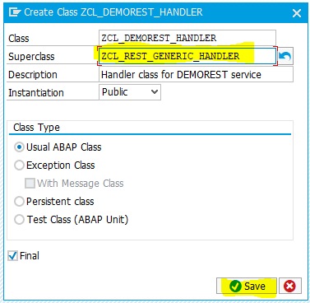

## Step 2🡪 Re-Define abstract method ‘SET_RESOURCE’

In this step, we need to specify the RESOURCE class name (Created in step 3), by setting global attribute GV_RESOURCE_CLASS:

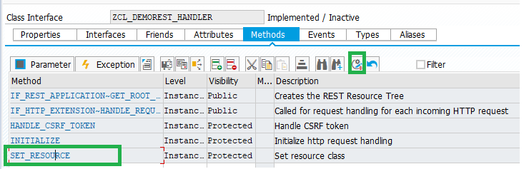

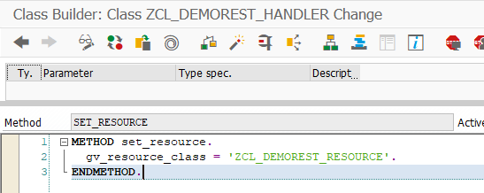

## Step 3: Inherit generic resource class to create your resource class

Create a child final class by inheriting abstract class **ZCL_REST_GENERIC_RESOURCE** as below (T-code SE24):

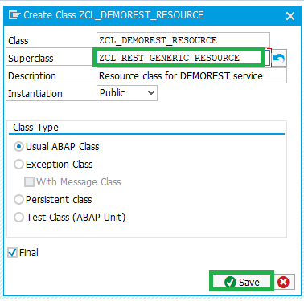

Note: Make sure that the name of the new class is same as specified in step 2.

## Step 4🡪 Re-Define abstract method ‘FM_FOR_ROUTE’

In this step, we need to specify route and Function Module mapping:

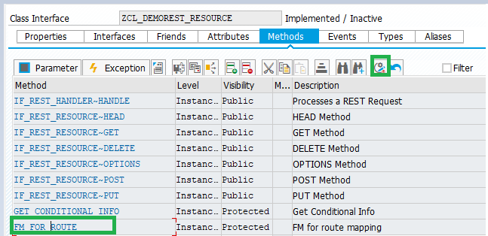

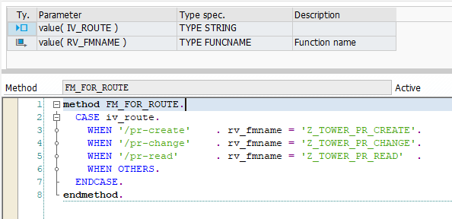

## Step 5 🡪 Create SICF Node and map Handler class created

Go to t-code SICF and create new sub element at your desired path and map Handler class name as below:

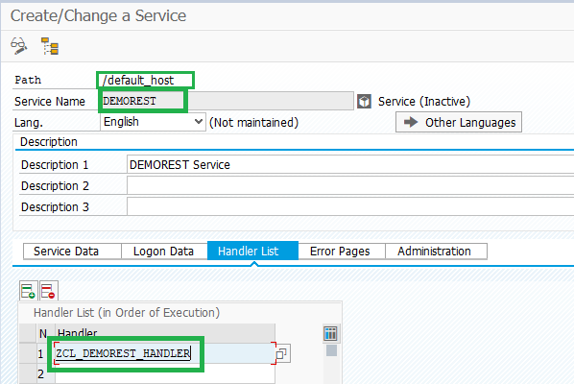

Note: Ensure to activate the node after creation:

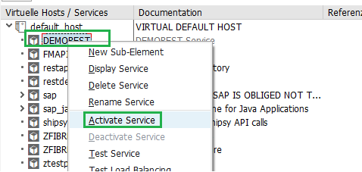

# Conclusion

That’s all required from development end. Once the service is activated, your rest service is ready for testing, loaded with in-built features mentioned.

# Generated URLs

The service node link can be found by right clicking the service in SICF and then clicking on ‘Test service’. This action should fire-up your browser and you can copy the link.

Please note, to access the core service, you still need to append the route for the required FM in the generated URL at end.

For example, in this case Following URLs are active for FM ‘Z_TOWER_PR_READ’:

|  |  |  |
| --- | --- | --- |
| Method-Type | URL | Result |
| GET | <http://deverpd91.bss.dev.jio.com:8000/demorest/pr-read?sap-client=112> | {      "SIGNATURE": {          "NAME": "Z_TOWER_PR_READ",          "DESCRIPTION": "PR creation",          "IMPORTING": [              {                  "PARAMETER": "INPUT",                  "REQUIRED": "false"              }          ],          "EXPORTING": [              {                  "PARAMETER": "OUTPUT",                  "REQUIRED": "false"              }          ],          "CHANGING": [],          "TABLES": []      },      "METADATA": {          "INPUT": {              "UNIQUE_ID": {                  "DATATYPE": "CHAR",                  "LENGTH": 18,                  "DESCRIPTION": "Length 18 text"              },              "PR_NUM": {                  "DATATYPE": "CHAR",                  "LENGTH": 10,                  "DESCRIPTION": "Purchase Requisition Number"              }          }      }  } |
| GET | <http://deverpd91.bss.dev.jio.com:8000/demorest/pr-read?sap-client=112&template=true> | {      "INPUT": {          "UNIQUE_ID": "",          "PR_NUM": ""      }  } |
| POST | <http://deverpd91.bss.dev.jio.com:8000/demorest/pr-read?sap-client=112> | FM Z_TOWER_PR_READ is called if active x-csrf token is passed in header. |